ADVANCED DATA STRUCTURES - PROJECT REPORT
216-A

SEAM CARVING
By
RANJITH KUMAR K(2019501102)

Abstract:

Effective resizing of images should not only use geometric constraints, but consider the image content as well. We present a simple image operator called seam carving that supports content-aware image resizing for both reduction and expansion. A seam is an optimal 8-connected path of pixels on a single image from top to bottom, or left to right, where optimality is defined by an image energy function. By repeatedly carving out or inserting seams in one direction we can change the aspect ratio of an image. By applying these operators in both directions we can retarget the image to a new size.

- Introduction:

Seam-carving is a content-aware image resizing technique where the image is reduced in size by one pixel of height (or width) at a time. A vertical seam in an image is a path of pixels connected from the top to the bottom with one pixel in each row; a horizontal seam is a path of pixels connected from the left to the right with one pixel in each column. For instance, if there is a 505-by-287 pixel image, result image after removing 150 vertical seams, resulting in a 30% narrower image. Unlike standard content-agnostic resizing techniques (such as cropping and scaling), seam carving preserves the most interest features (aspect ratio, set of objects present, etc.) of the image.

2.Terms and Methods Implemented:

- Energy calculation. The first step is to calculate the energy of each pixel, which is a measure of the importance of each pixel—the higher the energy, the less likely that the pixel will be included as part of a seam (as we'll see in the next step). In this assignment, you will implement the dual-gradient energy function, which is described below.

- Seam identification. The next step is to find a vertical seam of minimum total energy. This is similar to the classic shortest path problem in an edge-weighted digraph except for the following:
- The weights are on the vertices instead of the edges.
- We want to find the shortest path from any of the W pixels in the top row to any of the W pixels in the bottom row.
- The digraph is acyclic, where there is a downward edge from pixel (x, y) to pixels (x − 1, y + 1), (x, y + 1), and (x + 1, y + 1), assuming that the coordinates are in the prescribed range.
- Seam removal. The final step is to remove from the image all of the pixels along the seam.

3.API Implemented
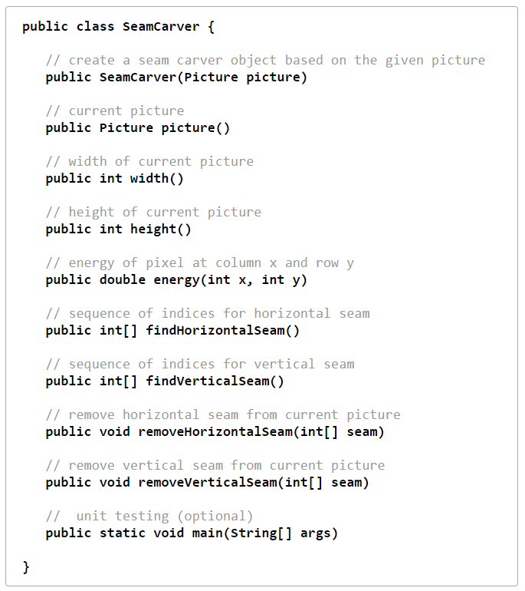

4.Web Submission

The project completed and submitted in the coursera for garding.
All test cases passed obataining 80% score overall.
The project files are submitted in the git and LMS along with the report.

REFERENCES:

https://github.com/ranjith210297/ADS-2_2019501102/tree/master/Project-2(SEAM%20CARVING)

https://coursera.cs.princeton.edu/algs4/assignments/seam/specification.php

